Networking Case Study
- Link: Design a network solution -BI enterprise application

Requirements
As the Tailwind Traders Enterprise IT team prepares to define the strategy to migrate some of the company’s workloads to Azure, it must identify the required networking components and design the network infrastructure necessary to support them. Considering the global scope of its operations, Tailwind Traders will be using multiple Azure regions to host its applications. Most of these applications have dependencies on infrastructure and data services, which will also reside in Azure. Internal applications migrated to Azure must remain accessible to Tailwind Traders users. Internet-facing applications migrated to Azure must remain accessible to any external customer.
To put together the networking design, the Tailwind Traders Enterprise IT team chose a key application, which is representative of the most common categories of workloads that are expected to be migrated to Azure:
BI enterprise application
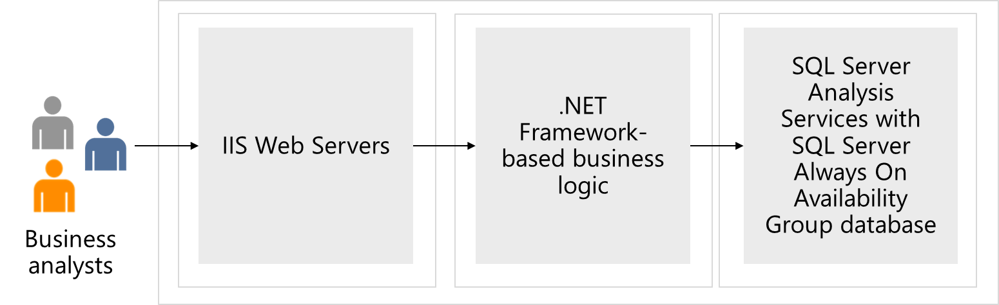
- An internal, Windows-based, three-tier business intelligence (BI) enterprise application with the front-end tier running IIS web servers, the middle tier hosting .NET Framework based business logic, and the back-end tier implemented as a SQL Server Always On Availability Group database.
- This application is categorized as mission-critical and requires high availability provisions with the availability SLA of 99.99% and disaster recovery provisions, with 10-minute RPO and 2-hour RTO.
- To provide connectivity to internal apps migrated to Azure, Tailwind Traders will need to establish hybrid connectivity from their on-premises datacenters. The Enterprise IT group already decided that connectivity will be implemented by using ExpressRoute circuit from its main Seattle datacenter, however, at this point it is not clear yet what would be failover solution in case that circuit becomes unavailable. The Tailwind Traders CFO wants to avoid paying for another, redundant ExpressRoute circuit.
- There are other considerations that apply to on-premises connectivity to internal apps migrated to Azure. Since the Tailwind Traders Azure environment will consist of multiple subscriptions and, effectively, multiple virtual networks, to minimize cost, it is important to minimize the number of Azure resources needed to implement core networking capabilities. Such capabilities include hybrid connectivity to on-premises locations as well as traffic filtering. Incidentally, this need to minimize cost aligns with the Information Security and Risk requirements, which state that all traffic between on-premises locations and Azure virtual networks must flow via a single virtual network, which will be hosting components responsible for hybrid connectivity and traffic filtering.
- As per requirements defined by the Tailwind Traders Information Security and Risk teams, all communication between Azure VMs in different tiers that are part of the same application must allow only the ports needed to run and maintain the application. However, due to IP address space limitations, it might not be possible to allocate dedicated subnets to each tier. Enterprise IT group needs to identify the optimal way to configure source and destination for traffic filtering that would not require directly referencing IP addresses or IP address ranges.

Tasks
- Design a 3-tier network solution for the BI Application. Your design could include
Azure ExpressRoute, VPN Gateways, Application Gateways, Azure Firewall, and Azure Load Balancers. Your networking components should be grouped into virtual networks and network security groups should be considered. Be prepared to explain why you chose each part of the solution.
- Based on your architect solution from the compute case study how would this affect the network design? Would you need any other networking resources to secure access to the modernized application? Would you no longer need some of the recommended solutions implemented in your original network design?
- Based on your storage (relational) case study how would you update the network design to secure access to the storage account and ensure only select users have access to the storage account?
- Based on the modernizing of the SQL backend how do you plan to enable pragmatic access to the database so that the front end has no hard coded secrets in its code base?

Instructor Solution - BI Enterprise application
Design a 3-tier network solution for the BI Application. Your design could include Azure
ExpressRoute, VPN Gateways, Application Gateways, Azure Firewall, and Azure Load Balancers.
Your networking components should be grouped into virtual networks and network security groups should be considered.
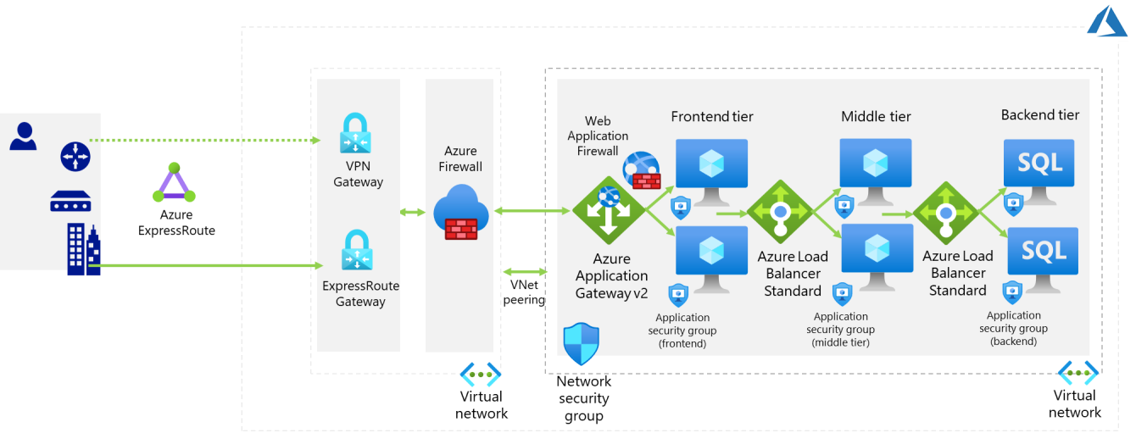
- The BI application is categorized as enterprise, which means that it requires the availability SLA of 99.99%. To accomplish this level of availability, you need to deploy Azure VMs hosting the application into Azure availability zones, which implies that the load balancers you will be using must support zone redundancy.
- You can choose between internal (private) zone-redundant Azure Load Balancer Standard SKU and zone-redundant Azure Application Gateway v2. The latter is required for the front-tier to accommodate the Information Security and Risk team requirement that any data-driven external and internal apps that support database updates must implement traffic inspection that would identify and block exploits targeting common web and database vulnerabilities, such as SQL injection or cross site scripting. This functionality is provided by the Web Application Firewall (WAF) component of Azure Application Gateway.
- For the middle and back-end tier load balancing, you should use zone-redundant Azure Load Balancer Standard SKU, which, unlike Application Gateway, supports non-HTTP/HTTPS traffic.
- You should use a combination of Network Security Groups and Application Security
Groups. For this to work as intended, you need to assign a specific Application
Security Group (such as, SQL Servers) to network adapters of the VMs hosting SQL Server instances. This way, within rules of a network security group assigned to the network adapters of Azure VMs in the tier that needs to connect to SQL Server instances, you can use the SQL Server application security group as the rule destination.
- To implement failover, you would first need to set up a matching, three tier deployment in another Azure region, serving as a disaster recovery site. For the web and middle tier, you can do this by using Azure Site Recovery. For the data tier, you
can extend Always On Availability Group to include another SQL Server instance in another region, with asynchronous replication from the primary instance.
- Note that this requires setting up global peering to the virtual network hosting the secondary site. To perform a failover, you can use Azure Site Recovery. This will also require DNS changes to update IP addresses of DNS records representing the names used for communication between tiers and for connectivity to the application from internal users.
- If using Azure functions for the middle tier, then private endpoint can be used to secure functions to the network.
- If using containers for the compute solution enable containers to use Azure Virtual Network capabilities
- programmatic access to SQL: managed identity
- Optional Review - How would you summarize networking technologies used for the application?
Network requirement | BI application
Web tier load balancing | Azure Application Gateway v2 with Web Application Firewall (WAF)
Middle tier load balancing | Azure Load Balancer Standard
Data tier load balancing | Azure Load Balancer Standard
Traffic filtering between tiers | Network Security Groups combined with Application Security Groups
High availability networking components: | Azure Load Balancer Standard (zoneredundant)  Application Gateway v2 (zone-redundant)
Disaster recovery networking components | Global virtual network peering  DNS (Azure Private DNS or custom DNS, including support for AD DS-integrated DNS zones)
- Optional Review - How would you summarize networking technologies used for hybrid connectivity and virtual network connectivity (including topology, primary and backup interconnectivity, and traffic filtering)?
Hybrid connectivity | Virtual network connectivity
Topology: Hub and spoke (single point of entry) | Topology: Hub and spoke
Primary interconnectivity technology: ExpressRoute (zone-redundant) | Primary interconnectivity technology:  virtual network peering
Backup interconnectivity technology: VPN Gateways (zone-redundant) | Backup interconnectivity technology: N/A
Traffic filtering: Azure Firewall | Traffic filtering: Azure Firewall (across spokes)
 | Network Security Groups and Application Security Groups within virtual networks
Traffic routing: BGP | Traffic routing: BGP + Azure User Defined Routes

Instructor references
Best practices to set up networking for workloads migrated to Azure - Cloud Adoption Framework | Microsoft Docs

